**Experiment Name :** FIFO Page Replacement Algorithm

**Experiment No:** 08

**Objectives:** In this lab we willLearn about FIFO page replacement algorithm and Implement of FIFO page replacement algorithm by using c program. And testing the program different input and find output .

**FIFO page replacement algorithm:**

In a operating systems that use paging for memory management, page replacement algorithm are needed to decide which page needed to be replaced when new page comes in. Whenever a new page is referred and not present in memory, page fault occurs and Operating System replaces one of the existing pages with newly needed page.

**CODE:**

#include<stdio.h>

int main()

{

int i,j,n,no,k,avail=0,count=0,value[50],frame[10];

printf("\n Enter the number of pages ");

scanf("%d",&n);

printf("\n Enter the pages :\n");

for(i=1; i<=n; i++)

scanf("%d",&value[i]);

printf("\n Enter the number of frame : ");

scanf("%d",&no);

for(i=0; i<no; i++)

frame[i]= -1;

j=0;

printf("Ref string\t page frames\n");

for(i=1; i<=n; i++)

{

printf("%d\t",value[i]);

avail=0;

for(k=0; k<no; k++)

if(frame[k]==value[i])

avail=1;

if (avail==0)

{

frame[j]=value[i];

j=(j+1)%no;

count++;

for(k=0; k<no; k++)

printf("%d\t",frame[k]);

}

printf("\n");

}

printf("\nPage Fault Is %d\n",count);

return 0;

}

**Output:**

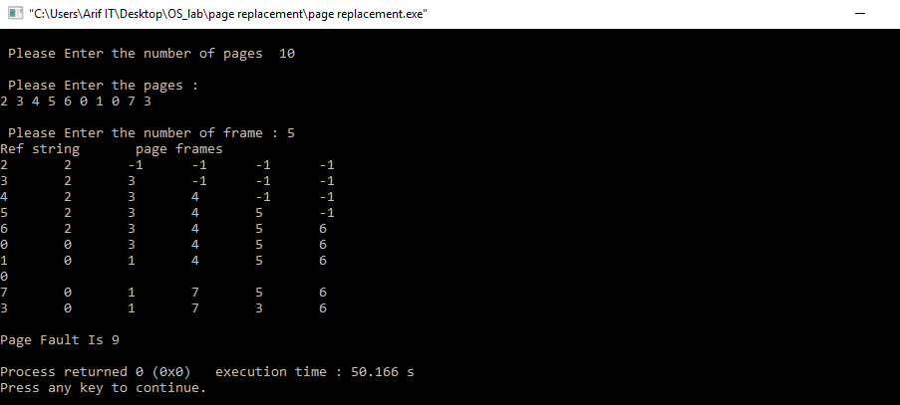

**Conclusion:**

After doing this labreport we learn about FIFO page replacement algorithm and we do the implement of FIFO page replacement by using C program successfully.We learn about that page replacement algorithm are needed to decide which page needed to be replaced when new page comes in .